**7Adriin.com Web Portal Functionality**

**Users Type**

* Freelancers: This group of user will only be able to create there gigs *for cross selling directly to clients* and work over project posted by Employer/Customer *& managed by 7adriin.com team as project management.*
* Employer/Customer: This user group can *do the following:-*

1. *Purchase directly in Marketplace store provided by freelancers*
2. *Post Project which 7adriin.com team will interfere & manage this process between freelancers & clients the interaction on post project will be managed by 7adriin.com team which they will provide final quotation to client add their margin and manage project between two individual*

**FREELANCERS SECTION**

**Freelancers Registration**

Freelancer registration require the following: -

* Full Name as on Passport
* Country
* Residence Country
* Contact Number
* Home Address
* Age
* Description of his field of Expertise
* Language and Level of each language
* Linked account details
* Category of Expertise & Sub Category
* Description of education background, services to deliver
* Document upload: Valid Passport Copy, Education level [Optional], Certifications [Optional]
* Upload Picture of freelancer in the portfolio
* Email & verification
* New user can register via their mail id.
* Payment referred two options: Wire Transfer to bank account & Western Union
* Preferred language of communication Arabic or English or Both
* User can choose their profession as employee, freelancer or both.
* User will receive the conformation mail from the respective site.
* Freelancer should update his/her profile in Arabic and English to be replicated in both sites languages.

Once user submit the user signup form, an email will be sent to user over provided email address. And SMS Token will be sent to the User Mobile Phone. Once received, user will enter the email and sms token over the website.

* On this, the request will be sent to 7Adriin team [CMS] to review and approve the account.
* Once account is approved, email will be sent to freelancer that he/she can sell the services. Now.

**Login**

* The existing user can login with valid username and password.
* In case of forgot the password, there is an option of recovery password.
  + On this, a random generated password will be sent to the email.
  + User will enter the random generated password.
  + Once logged in, user will have option to change the password bye entering old password and new password twice along with security captcha.

**Post Login: Home Screen**

* A top menu will appear with user picture indicating user properties. Upon clicking
  + There will be My Profile, which upon clicking user can view his Gigs, his entire profile saved along with skills.
  + User will have an option to edit his general information. Add/Remove Education, Skills and languages.
  + There will be Account Setting, which upon clicking will provide user to change password [Old and New password twice required along with security captcha]. There will be option to change contact number. If new number is entered, a SMS will be sent with OTP to the new number. That needs to be entered in order to change the number successfully.
* There will be option of selling which indicates selling services option.
  + Under Selling, user can see His Order Details
  + User can view his GIGS related page
  + User can see Analytics, where he will be able to view his earnings, order details completed, orders in progress and New Orders.
  + Under Analytics, there will be comments provided by different customers against freelancer for the work he have performed.
  + There will be options of Earning. Which will have details of Net Income, Withdrawn so far, Pending Clearance and available for Withdrawal.
  + User will have an option to withdraw available amount. To his Bank through Bank Transfer Option. Once request, the request will go to 7Adriin Admin Team for processing with Processing Status. Below user will be able to view details of all the withdrawals performed so far.
* There will be option of Messages, which will take user to the inMail Inbox.
* Freelancer can view the recent activities.
* Freelancer can receive notification relevant to their profile.
* Freelancer also can view the statistic details of their activity.
* Freelancer can perspective the credit details via dashboard.
* Freelancer can view the project details.
* Freelancer has advanced option of quick search for their favorites as add to favorite.
* Label in freelancer note that below mechanism in freelancer drop box once he/she pick the language
* If freelancer choice preferred language Both languages his/her profile will be shown in both Arabic & English websites. He/she update profile in English & Arabic.
* There will be option of Buyers Request. A request comes in here, when a buyer posts a quotation for specific project work. Based on the Project Category / Sub Category and freelancers available Gigs. If there 3 are matched. A request will be available where Freelancer can submit his GIG to the Customer as an offer to work.
* Once Gig is submitted against a request, and paid by client, it will appear as Active Work under Freelancers Orders.
* There will be an icon for User Dashboard. Which will take user to Dashboard.
* Under menu, another Category and Sub-Category menu will be available. Upon clicking, the webpage will loan all the gigs sorted on the basis highest good reviews will be displayed in BOXES shape will be displayed.

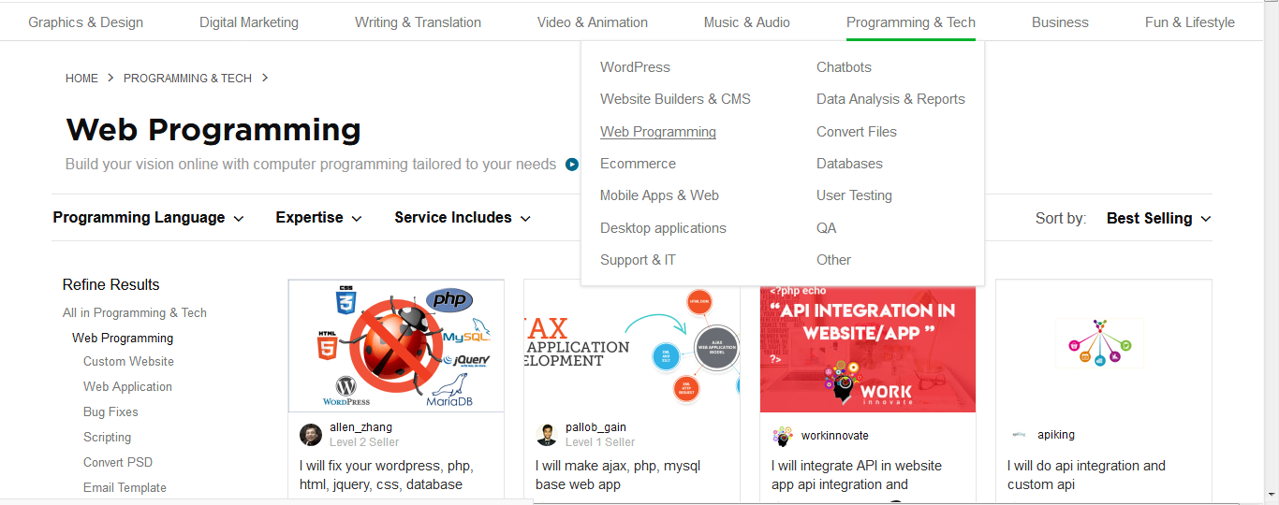

* Upon clicking, freelancer will be taken to the gig page for viewing purpose only. However it cannot be purchased using Freelancer Account.

**Gigs Available over Homepage**

* Under the user menu and Category/Subcategory, different group of gigs will be available.
* The First Group will be for recently viewed gigs along with SEE ALL option and horizontal scroll.



* Next group will be related to the freelancer’s category and Sub Category Expertise that was selected during the login creation.

**Freelancer Dashboard**

* Freelancer Dashboard will show order statistics, monthly earning statistics and inbox counter where user can go and view his inbox for inmail messages and credit balance.

**Gigs Management**

Freelancer can create his gigs that will be available for viewing by other freelancers, and customer can buy those gigs.

* If there are gigs published by freelancer, it will be visible to logged in freelancer under his homepage.
* Under Selling Menu, there will be an option for GIGS.
* Once opened, user will be able to view his Active Gigs in List/Grid Form, Draft Gigs, Paused Gigs and Expired Gigs.
* There will be option to Create New Gig as many freelancers wants
* Upon Clicking the existing Gig, user will be taken to EDIT GIG page.

**NEW GIG**

* A gig is a template of services that freelancer can offer and can be purchased by employer.
* Section would be Overview, Pricing and Gallery.
* Gig Overview will contain
  + Gig Title: This will be a short description of 100 character that will be used a GIG Title.
  + Category : Dropdown as per CMS
  + Sub Category : Dropdown as per Category set from CMS
  + Service Type : Dropdown as per Category /Sub Category set from CMS
  + Refinement Tag: User can provide Custom Metadata Tags suitable for SEO. The more tags used, more refined services are cleared.
  + Gig Details: A detailed description of gig that would help customer better understanding of what is being offered.
* Gig Pricing
  + There will be 3 Package Offering. Basic / Standard / Premium. Allowing user to sub-categorize there gig based on 3 services.
  + User will Provide Package Title, Package Description, Delivery Time, Additional Details based on Gig Offering and Price.
* Gig Gallery
  + User will have to upload pictures relate to Gig 3 Maximum. One picture can be selected a title picture that is mandatory.
  + User can also upload PDF to further clarify the service. Optional. 2 Maximum
  + Use can also upload Video. Optional.[Less than 50 MB]. 1 Maximum

Freelancer will also have an option to write down the required information in Arabic. However this will be optional. Once all information is added, user can save the GIG. Upon saving, the gig will be in DRAFT Mode and will be available under DRAFT section of user gigs. Then an option will appear to Publish Gig. Upon this, the GIG will be active. This gig will be available under user Active Gig and will be available.

**ORDER GIG [Order Lifecycle]**

Once any customer buys a package under a gig or approved a gig against any project request that is posted by the customer, an InMail along with email will be sent to freelancer as notification. Under Selling -> Order, there will be list of orders that will be categorized on the basis of New, Active, Late, Delivered, and Completed.

* Once a new order comes, it will come under New. However to start, the freelancer will have to accept the customer’s request to initiate working. However each order will have its own communication thread. Under which the Customer and Freelancer can communicate. All will be shown under inMail as well. Once all information has been exchanged, which can be anything related to the service being offered, the freelancer will have to start the task by Approving the Order.
* Upon approving, the order will shift to Active Order. Based on the service purchased for number of days, the activation date time will start. The Freelancer will have a visible deadline to submit the work.
* If an active order breaches the time limit, it will enter into LATE state. And will be visible under Late Category.
* Once order is completed either from Active or Late Category, upon freelancer’s selection. It will be moved to delivered state.
* At delivered state, the customer will review the work and set the order to COMPLETED Category.
* Freelancer and Customer can have any sort of discussion over InMail while the order is in any category.

Once work is done, the 7adriin will transfer the task amount to freelancer account that can be request to be withdrawn later.

**Gig Rating**

Once a job is done, a gig can be rated out of 5 stars. Reviews will also be available that will be posted by Customer. More stars means the gig will appear on top lists of searches.

**CUSTOMER/EMPLOYER SECTION**

**Customer Registration**

* Client has easy sign-up either by Email direct registration form within 7adriin website, or Facebook, verification on email based.
* Full Name as on Passport
* Country
* Residence Country
* Contact Number
* Home Address
* Age through DOB
* Upload Picture of freelancer in the portfolio
* Email & verification
* Payment referred two options: Wire Transfer to bank account & Western Union
* User will receive the conformation mail from the respective site.

**Login**

* The existing user can login with valid username and password.
* In case of forgot the password, there is an option of recovery password.
  + On this, a random generated password will be sent to the email.
  + User will enter the random generated password.
  + Once logged in, user will have option to change the password bye entering old password and new password twice along with security captcha.

**Post Login: Home Screen**

* A top menu will appear with user picture indicating user properties. Upon clicking
  + There will be My Profile, which upon clicking user can view his Orders in grid form if available. Orders will be categorize as Pending Payment [Where order payment needs to be paid along with service fee to 7adriin], New [Awaiting confirmation from Freelancer], Active, Late, Completed, his entire profile saved along with skills.
  + User will have an option to edit his general information.
  + There will be Account Setting, which upon clicking will provide user to change password [Old and New password twice required along with security captcha]. There will be option to change contact number. If new number is entered, a SMS will be sent with OTP to the new number. That needs to be entered in order to change the number successfully.
  + User can see Analytics, where he will be able to view his Spending, order details completed, orders in progress and New Orders.
* There will be option of Messages, which will take user to the inMail Inbox.
* There will be option of Buying. Under which [These options are briefed in next section]
  + There will be an option to Post Project Request
  + Manage Request
  + Orders
* There will be an icon for User Dashboard. Which will take user to Dashboard.
* Under menu, another Category and Sub-Category menu will be available. Upon clicking, the webpage will loan all the gigs sorted on the basis highest good reviews will be displayed in BOXES shape will be displayed.



* Upon clicking, freelancer will be taken to the gig page for viewing purpose only. However it cannot be purchased using Freelancer Account.

**Gigs Available over Homepage**

* Under the user menu and Category/Subcategory, different group of gigs will be available.
* The First Group will be for recently viewed gigs along with SEE ALL option and horizontal scroll.



**Customer Dashboard**

* Freelancer Dashboard will show order statistics, monthly spending statistics and inbox counter where user can go and view his inbox for inMail messages & **credit** balance.

**Buying a Gig/Service**

Based on available gigs, either over the homepage or through search service or by going into Category/Sub Category. Upon clicking the gig. A webpage will open with all details about the gig. Customer will have an option to Save the Gig and this can be processed later on which is accessible through Buying -> Saved option.

It will be displayed as in FIVERR but with the options that are set for 7adriin only.





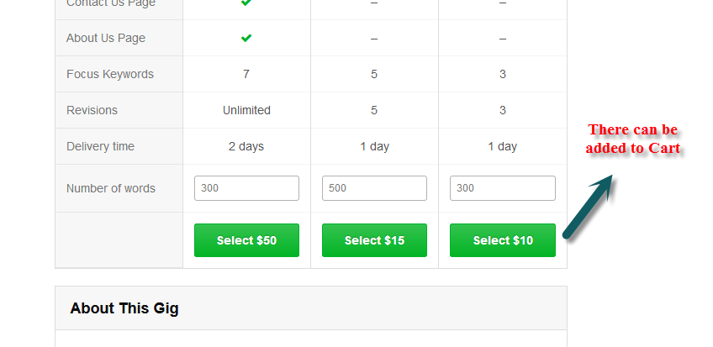

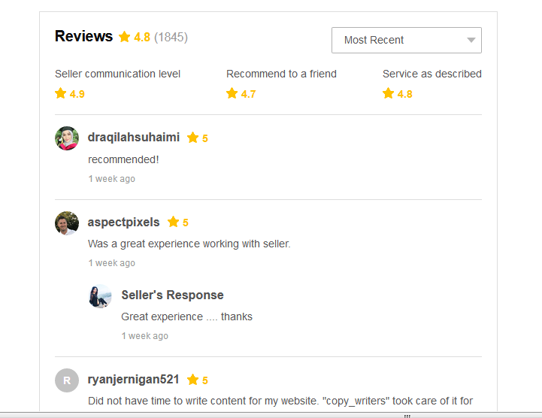

* A gig once opened, will display all the properties as shown in above screenshots. All attached images, video, pdf along with description, packages will be displayed.
* Each package will have SELECT option. Upon clicking, the application will add the GIG Package in Cart and will proceed to checkout.
* Only 1 gig package can be proceed at a single go.
* However user can add quantity which will multiply the amount which will also increase the service charge as per the total amount. Upon this, the Gig will be placed under New Order section.
* As it proceed, user will perform the online payment. Once payment is done, the Gig Order will be active.
* During this, the Customer can also inMail the Freelancer to discuss the services before proceeding with an order.
* Once payment is Done, Customer will click on Start Order, which will be intimation that Gig Order has been started and Order will be available under Active Order for Freelancer. The timer will initiate which is discussed in Order Status in Freelancer Section.

**Customer Dashboard**

Freelancer Dashboard will show order statistics, monthly spending statistics and inbox counter where user can go and view his inbox.

**Buying Menu**

* + There will be an option to Post Project Request
  + Manage Request
  + Orders

This menu will be primary used by Customer to manage his orders. 3 options will be

* Post Project Request
  + A from will open with Descript of service that customer is looking for.
  + Attachment which will be optional. PDF, MS Word, MS Excel, Text File supported only
  + Category : Dropdown as per CMS
  + Sub Category : Dropdown as per Category set from CMS
  + Service Type : Dropdown as per Category /Sub Category set from CMS
  + Service Delivery Time. 3 options will be available. 1 Day, 3 Days, 7 Days and Customer Field where user can select 1 to 30 days maximum.
  + An optional budget field where customer can specify the project budget.
  + Once project request is submitted, all the freelancers who are having gigs against Category, Sub Category and Service Type will be notified.
  + Upon saving, the project request will be moved to Manage Request section under ACTIVE.
* Manage Request
  + There will be 3 categories. Active, Paused and Completed.
  + Under Active, a project request will be available that are active.

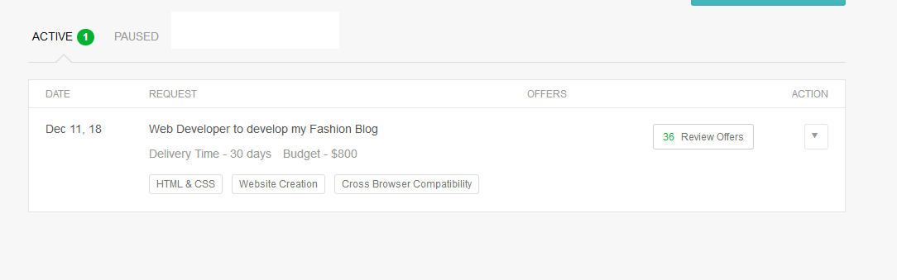

* + There will be action dropdown that can pause the Project Request.
  + There will be offers that will be available which are done by Freelancer.
  + Upon clicking on Review offer, all gigs that are submitted by Freelancer will be displayed here.

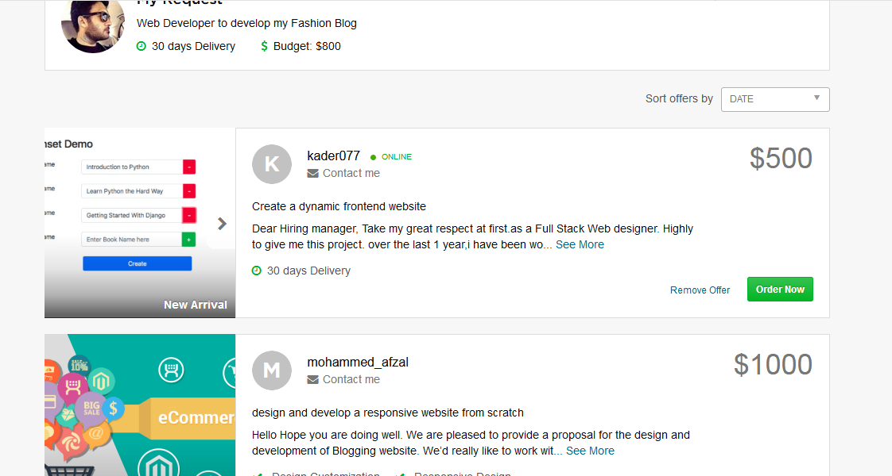

* + Offer can be removed. If customer clicks on Order Now, it will take user to checkout screen. Rest of the process will be same as of ordering Gig Service.
* Orders: There will be list of orders that will be categorized on the basis of New, Active, Late, Delivered, and Completed.
  + All orders that are pending payment will be under `
  + Upon approving from Freelancer, the order will shift to Active Order. Based on the service purchased for number of days, the activation date time will start. The Freelancer will have a visible deadline to submit the work.
  + If an active order breaches the time limit, it will enter into LATE state. And will be visible under Late Category.
  + Once order is completed either from Active or Late Category, upon freelancer’s confirmation. It will be moved to delivered state.
  + At delivered state, the customer will review the work and set the order to COMPLETED Category.
  + Freelancer and Customer can have any sort of discussion over InMail while the order is in any category.
  + Customer can provide feedback and rating for the completed order when the order status is being Completed.

**Dispute Management [Customer / Freelancer]**

Both customer and freelancer can open dispute against active or late status orders. Once dispute is opened, the order goes into DISPUTE mode. The order section in both Freelancer and Customer mode will have DISPUTE category in order where the disputed orders can be viewed along with comments from 7adriin team. The 7Adriin team will investigate the issue and decide accordingly. Both parties will be communicated.If required, the order can be reinstated or cancelled so task can be completed accordingly either by same freelancer or other as selected by Customer.

**Search Service [Customer / Freelancer]**

At the top left, there will be Search menu. Freelancer/Customer can type in any required service. Below is similar implementation.

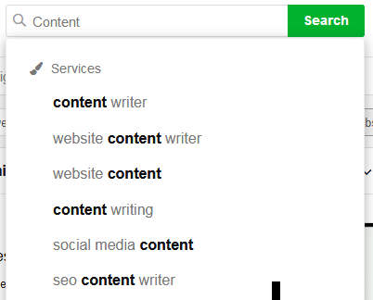

* If a service is searched, similar naming services will appear which mean gigs of same nature will be available. Any gig having a search word in description of title will appear before user.

**Bidding Module**



* Client send free Post Project into 7adriin.com (Later phase we will charge for this posting ensure feature capable easier to be chargeable)
* Automatically trigger message/email to all categories freelancer under the name of 7adriin Account Manager without mention budget.
* Account Manager will be receiving Offers from invited freelancers per the categories separately from freelancers without knowing each freelancers how much the other bid.
* Account manager will provide final Offer to customers with 7adriin margin manually need to be edited.
* Once Customer paid the offer account manager will be allocated to the customer for the project delivery.
* Account Manager will allocate the awarded freelancer to work in the project
* Freelancer will not know who is the client he/she will be dealing with 7adriin account manager only.
* Customer will be updated on the project by our Account Manager until the delivery.
* Account Manager will ask client about the feedback on auto notification/email , 7adriin management onbehalf of the client will post the rating & feedback on feedback feature of the freelancer.